##### AEPES

##### Semester 1 Examination, 2023



##### Question/Answer Booklet

**Students, please place your name in this box**

**Time allowed for this paper**

Reading time before commencing work: Ten minutes

Working time for paper: Two and a half hours

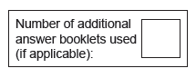 **Materials required/recommended for this paper**

***To be provided by the supervisor***

This Question/Answer Booklet

Multiple-Choice Answer Sheet

Extended answer booklet (lined paper)

***To be provided by the candidate***

Standard items: pens (blue.black preferred), pencils (including coloured), sharpener, correction fluid/tape, eraser, ruler, highlighters

Special items: non-programmable calculators approved for use in the WACE examinations

**Important note to candidates**

No other items may be taken into the examination room. It is **your** responsibility to ensure thatyou do not have any unauthorised notes or other items of a non-personal nature in the

examination room. If you have any unauthorised material with you, hand it to the supervisor

**before** reading any further.

### **Structure of this paper**

|  |  |  |  |  |
| --- | --- | --- | --- | --- |
| Section | Number of questions available | No. of questions to be attempted | Suggested working time (minutes) | Marks available |
| Section One:  Multiple-Choice | 20 | 20 | 20 | 20 |
| Section Two:  Short Answer | 9 | 9 | 70 | 65 |
| Section Three:  Extended Answer | 3 | 3 | 60 | 30 |
|  |  |  | Total | 115 |

**SECTION ONE: MULTIPLE CHOICE** **(20 marks)**

Record an answer for questions 1 – 20 by marking your choice on the separate Multiple-Choice Answer Sheet using a blue or black pen or a B or 2B pencil. Each question is worth one mark.

If you make an error, follow the instructions given to you on the Multiple-Choice Answer Sheet.

Suggested working time for this section is 20 minutes.

1. Which of the following muscles produces extension at the elbow?
2. Deltoids
3. Biceps
4. Quadriceps Group
5. Triceps

1. The tibialis anterior muscle contracts to cause which of the following movements   
   of the ankle joint?
2. Pronation
3. Dorsi flexion
4. Plantar flexion
5. Rotation
6. Which blood vessel would only carry deoxygenated blood?
7. Vena cava.
8. Aorta.
9. Pulmonary vein.
10. Capillaries.
11. The insertion point for the hamstring muscle is located on the:
12. Tibia.
13. Femur.
14. Patella.
15. Tarsals.
16. Which of the following is ***not*** a function of the skeleton
17. Attachment point for muscles
18. Protects vital organs
19. Storage of ATP
20. Produces red blood cells
21. Which of the following is ***not*** a function of the respiratory system
22. Circulate blood around the body
23. Provide a method for gas exchange
24. Create speech
25. Facilitate sense of smell
26. Identify the correct labels:
27. A – deltoid, B – gastrocnemius, C – radius, D – tarsals
28. A – pectoral, B – soleus, C – ulna, D – metatarsals
29. A – trapezius, B – tibialis anterior, C- ulna, D – tarsals
30. A – pectoral, B - tibialis anterior, C – radius, D - metatarsals

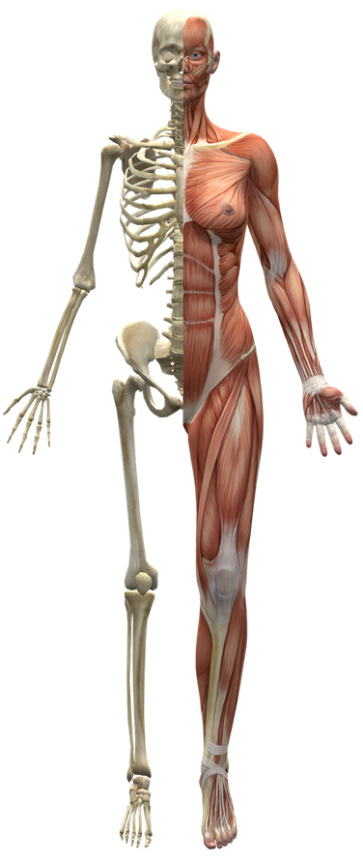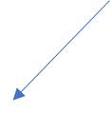

A

D

C

B

1. Which of the following are both an immediate response and a long-term adaptation to exercise?
2. Increased stroke volume
3. Increased blood flow to the muscles
4. Increased arterial *–* venous *O2* difference
5. All of the above
6. An athlete is said to be in oxygen deficit when their oxygen uptake is:
7. less than the oxygen required to produce sufficient energy aerobically
8. greater than the oxygen required to produce sufficient energy aerobically
9. equal to oxygen required to produce sufficient energy aerobically
10. below resting oxygen levels to produce energy aerobically
11. The primary food fuel for energy production during high intensity activity is
12. PC
13. Protein
14. Fats
15. Carbohydrates
16. For an athlete to increase muscular strength, he/she should:
17. Use heavy weights with many repetitions
18. Use light weights with many repetitions
19. Use heavy weights with few repetitions
20. Use lights weights with few repetitions
21. In the sport of rugby, the ball carrier has to react to the defence quickly, often changing his initial running direction. This is a characteristic of which component of fitness?
22. Muscular strength
23. Agility
24. Muscular power
25. Flexibility
26. Which of the following is **not an immediate response** to exercise?
27. Increased respiratory rate
28. Increased blood pressure
29. Decreased resting heart rate
30. Decreased creatine phosphate stores
31. The amount of air inhaled or exhaled with one breath is referred to as:
32. Respiratory rate
33. Stroke volume
34. Gaseous exchange
35. Tidal volume
36. Overloading the body during training can be achieved by varying three factors:
37. specificity, intensity, reversibility
38. intensity, frequency, duration
39. intensity, duration, recovery
40. time, frequency, specificity
41. A pre-season training session involves football players taking part in a modified form of continuous training, involving regular changes of pace in response to naturally occurring obstacles, such as hills. This training type is defined as
42. resistance training.
43. circuit training.
44. Fartlek.
45. plyometrics.
46. The gaseous exchange occurs during respiration to allow oxygen to be exchanged for the carbon dioxide which has been returned from the body. Where does this exchange take place?
47. in the nasal cavity, whilst the cilia filter out the unwanted waste gas
48. at the base of the trachea, in the two major branches of the bronchi
49. in the diaphragm as it contracts and relaxes to create pressure differential to allow  
     the exchange to take place
50. in the microscopic air sacs called alveoli, at the end of the bronchioles
51. Carbohydrates, fats and proteins play an important role in the production of ATP production. Which of the following statements is/are true?
52. carbohydrates are the primary fuel sources and are stored in the muscles as glycogen
53. protein is used as a fuel source in extreme circumstances, for example in ultra- marathons
54. carbohydrates can last for over four hours without replenishing
55. a and b
56. With reference to muscle contraction, which of the following statements is the most accurate?
57. attachment points allow a muscle to push and pull
58. muscle attachment at the stationary end of the bone is called the origin of a muscle
59. muscle attachment at the moving end of the bone is called the origin of a muscle
60. muscle attachment at the stationary end of the bone is called the insertion point of   
     a muscle
61. High Glycaemic Index (GI) food sources are most appropriate for athletes to:
62. provide muscles with a rapid source of energy immediately prior and during competition.
63. provides muscles with a means to recover, repair and grow
64. improve efficiency of the aerobic energy system during short intervals.
65. provide muscles with a sustained release of energy during competition.

**END OF SECTION ONE**

**SECTION TWO: SHORT ANSWER (65 MARKS)**

There are eight questions in this section. **Attempt all questions**.

Write your answer in the space provided. If room is insufficient, complete the question on the pages provided at the back of this booklet. Ensure that you clearly identify each answer.

Suggested working time for this section is 70 minutes.

**Question 1 (5 Marks)**

In the space provide draw and label a human heart.

**Question 2 (3 marks)**

Identify and briefly explain the different factors that make gas exchange in the lungs possible.

**Question 3 (9 marks)**

**(a)** Insert labels for the **three** types of blood vessels indicated in diagram. (3 marks)



**(b)** Compare and contrast the structure of these vessels. (6 marks)

**Question 4 (6 marks)**

Gymnasts, in order to avoid injury, train by stretching their muscles beyond normal resting length.

This increases the muscles extendibility.

Identify and define the **three** other characteristics of skeletal muscle.

**Question 5 (4 marks)**

CrossFit requires muscular contractions that differ between the exercise being executed.

Outline the **two** types of muscular contractions necessary for the following movements.

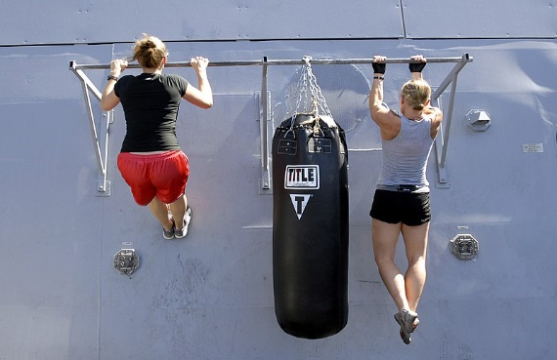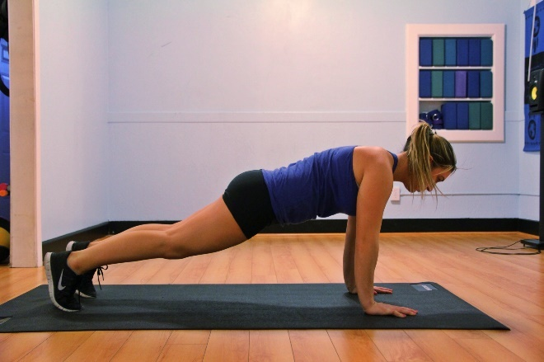

**Plank Pull Ups**

**Question 6 (10 marks)**

Below is an image of a soccer player preparing to kick a ball.

1. Label the two muscles labelled **A** and **B** in the box provided. (2 marks)
2. Label the insertion point and origin point of **muscle A** on the diagram. (2 marks)

A ____________________

B ____________________

1. Muscles work in pairs to create movement. Define the role of the origin and the insertion and explain how the muscles on the front and back of the thigh work together to create movement to flex the knee in preparation to strike the ball. (6 marks)

**Question 7 (11 marks)**

Athletes rely on the efficiency of their circulatory system to carry oxygen and nutrients around the body to all the cells, whilst removing waste products and carbon dioxide.

1. Blood is the main fluid in the circulatory system. Identify the four components found in the blood and outline their main function. (8 marks)

1. As an athlete begins their training session, several immediate, physiological responses occur in the body and the athlete will begin to experience an increase in body temperature. Account for the increase in temperature experienced by the athlete and describe how the body prevents overheating. (3 marks)

**Question 8 (11 marks)**

A long-distance runner will require very different components of fitness than a 50m freestyle swimmer.

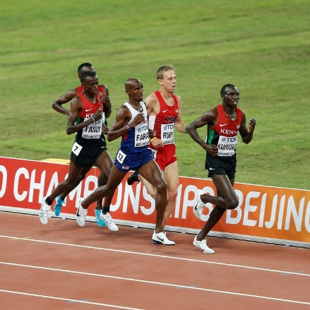 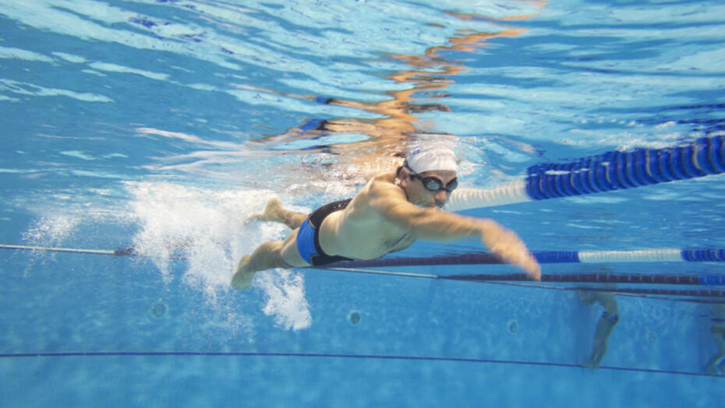

1. Identify and define the **two** components of fitness that would be the mostimportant for the long-distance runner and **two** components of fitness that would be the most important for the 50m swimmer (use different components for each athlete). (8 marks)

1. For either the long-distance runner or 50m swimmer, choose one of their main components of fitness and justify which training type would be most beneficial for them to include in their training program. (3 marks)

**Question 9 (6 marks)**

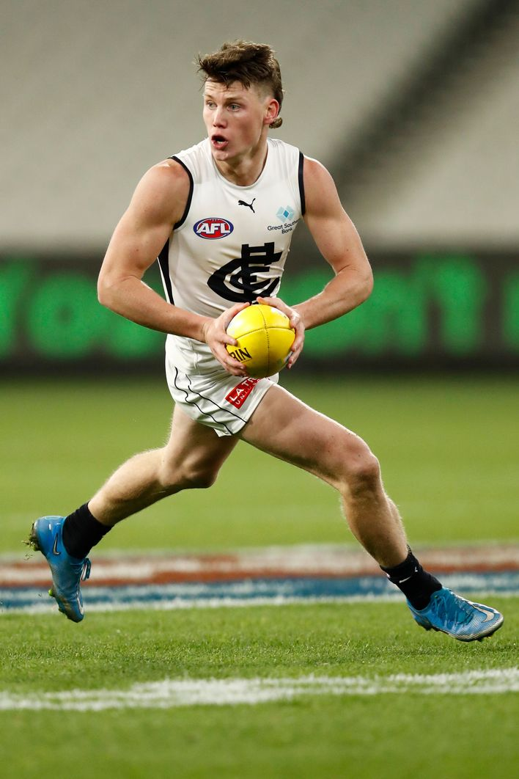

AFL is a highly demanding sport with some elite players running up to 15 kilometres in a game. Identify and describe three immediate responses of the circulatory system as a player is running around the field.

**END OF SECTION TWO**

**SECTION THREE: EXTENDED ANSWER (30 MARKS)**

There are three questions in this section. **Attempt all questions**.

Write your answers on the lined pages provided. Ensure that you clearly identify each answer.

Suggested working time for this section is 60 minutes.

**Question 10 (10 marks)**

In 2021, Western Australian Peter Bol became a household name after narrowly missing out on a medal at the Tokyo Olympics, placing 4th in the 800m final. During qualifying he ran an Australian national record of 1min 44.11secs.

Explain the mechanics of breathing that would have occurred during Peter Bol’s 800m race.

**Question 11 (10 marks)**

In 2022, Jai Hindley made history as the first Australian cyclist to win the three-week Giro d’Italia Grand Tour. Each stage ranged from 120km to over 200km, taking up to 6 hours in length to complete. Jai’s endurance has been extensively trained to endure the stress of competition since the weekly Perth river loops and hills training rides that he used to complete as a junior.



Using your knowledge of the long term cardiovascular and respiratory effects of training, discuss **five** chronic adaptations Jai would have developed as a result of his training to be able to compete at his optimal performance state.

**Question 12 (10 marks)**

Netball is a fast-paced game that requires multiple high intensity sprints and drives to receive the ball, followed by limited recovery between these bouts of effort, where lower intensity movement or rest takes place.

With reference to the energy system continuum, identify which energy system will predominantly fuel the netball player during these high intensity movements on the ball, provide justification for your choice.

______